**Lab 31**

**Name: Navneet P**

**Student ID: AF0411619**

**Topic: MySQL Introduction**

**What is MySQL?**

MySQL is an open-source relational database management system (RDBMS) that uses

structured query language (SQL) to manage and manipulate data in a database. It is

widely used for various applications, from small web applications to large enterprise

systems.

MySQL's key features include:

* **Scalability:** Capable of handling large amounts of data and concurrent connections.
* **Flexibility**: Supports various data types and storage engines.
* **Performance**: Optimized for speed and efficiency.
* **Reliability**: Known for its stability and robustness

**What are ER Diagrams?**

An Entity-Relationship Diagram (ERD) is a visual representation of the data model that shows the entities, attributes, relationships between entities, and cardinality. ERDs are commonly used in database design to help developers and stakeholders understand the structure and relationships within a database.

**Question 1:**

Create a Database & Table Using MySQL Command-Line Client.

1. Create a database with the name **StudentManagementSystem.**

Solution:

CREATE DATABASE StudentManagementSystem;

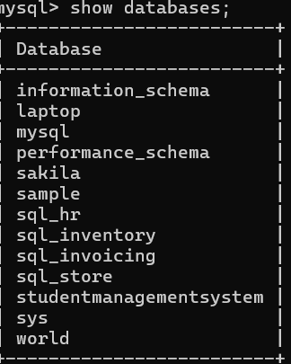

1. Create a table with named **Student** with attributes:

Solution:

CREATE TABLE student ( studentID INT PRIMARY KEY, firstName VARCHAR(30), lastName VARCHAR(30), dateOfBirth DATE, gender VARCHAR(10), email VARCHAR(30), phone VARCHAR(30) );

Output:

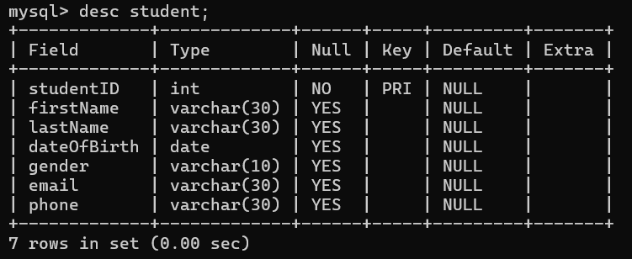

1. Create a table with name **Course** with attributes:

Solution:

CREATE TABLE course ( CourseID INT PRIMARY KEY, CourseTitle VARCHAR(30), Credits INT );

Output:

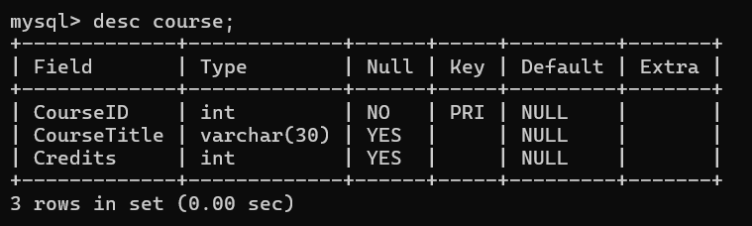

1. Create a table with named **Instructor** with attributes:

Solution:

CREATE TABLE instructor ( InstructorID INT PRIMARY KEY, firstName VARCHAR(30), lastName VARCHAR(30), email VARCHAR(30) );

Output:

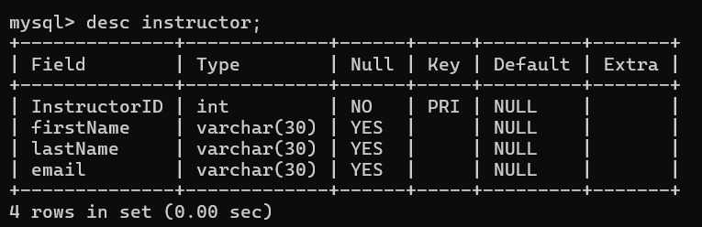

1. Create a table with named **Enrollment** with attributes:

Solution:

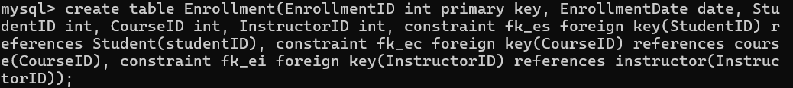

Output:

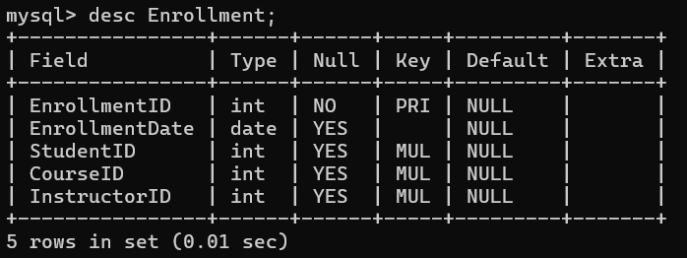

1. Create a table with named **Score** with attributes:

Solution:

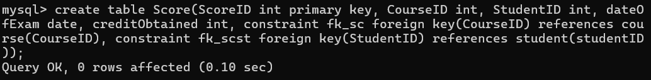

Output:

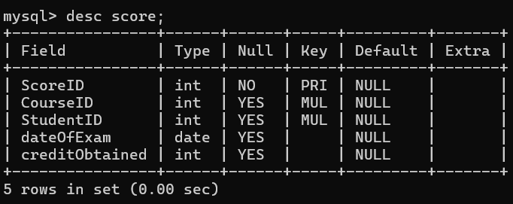

1. Create a table with named Feedback with attributes:

Solution:

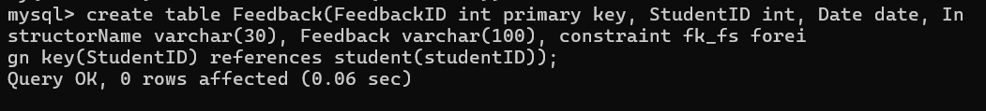

Output:

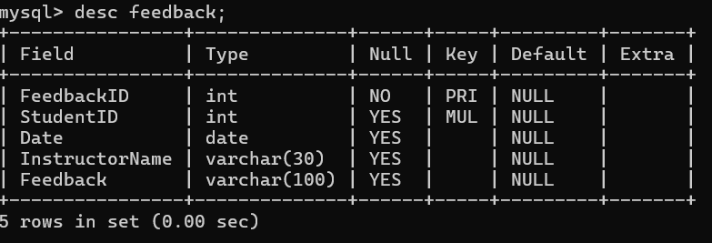

**Entity-Relationship Diagram for this database**

